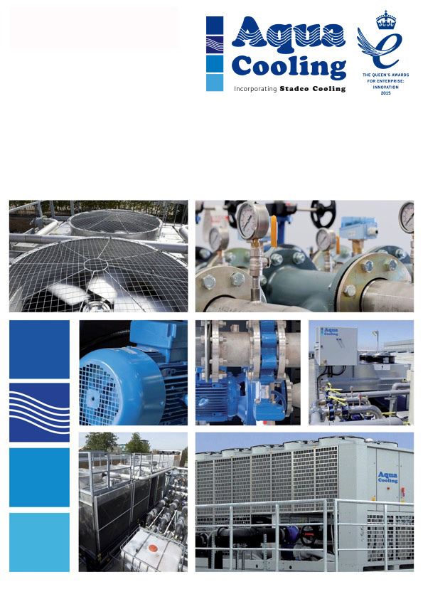

The complete solution to all your cooling needs

**NSCS 100-250/150/W46VCC4  
NSCS 100-160/40/W45VCC4  
Datasheets**

**Client: Q Cooling**

**CN: CN3217**